**Docker Lab expose & publish (-p)**

**Project Scenario: (Linux)**

Make container from a webserver and access it’s index page from anywhere (port mapping 80)

Make container from a Jenkins container and access it’s index page from anywhere (port mapping 8080)

**Practical Work:**

**# service docker start**

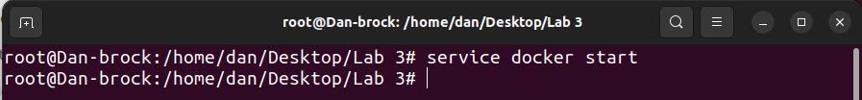

**# docker run -td --name techserver -p 80:80 ubuntu**

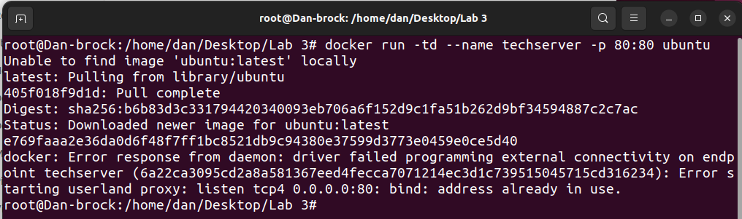

**# docker port techserver [check mapped ports detail]**

**80/tcp -> 0.0.0.0:80**

**80/tcp -> :::80**

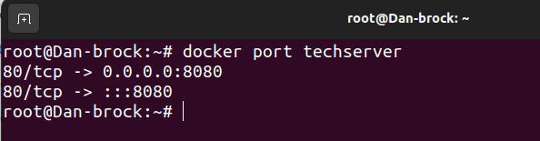

**[Enter the container & update]**

**# docker exec -it techserver /bin/bash**

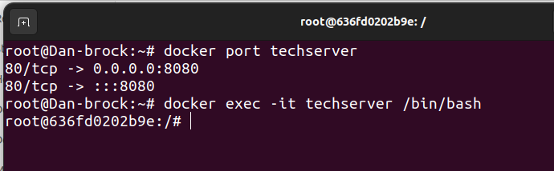

**# apt-get update**

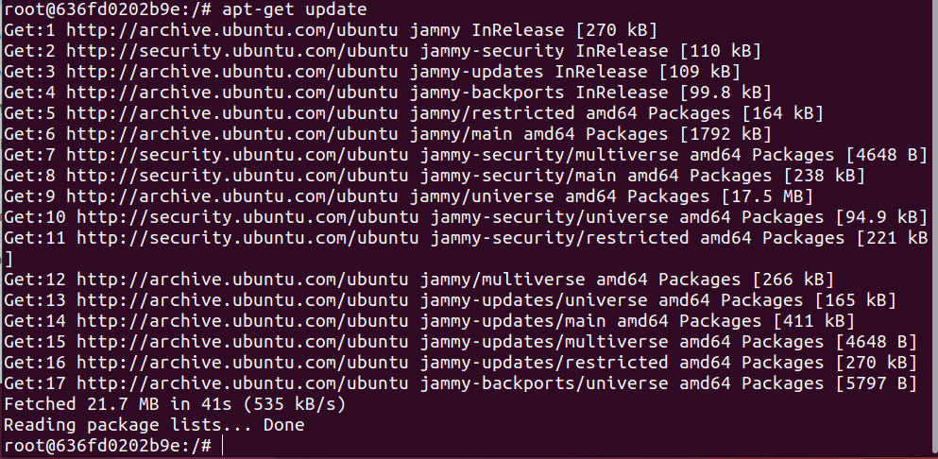

**[Install apache2 server]**

**# apt-get install apache2 –y**

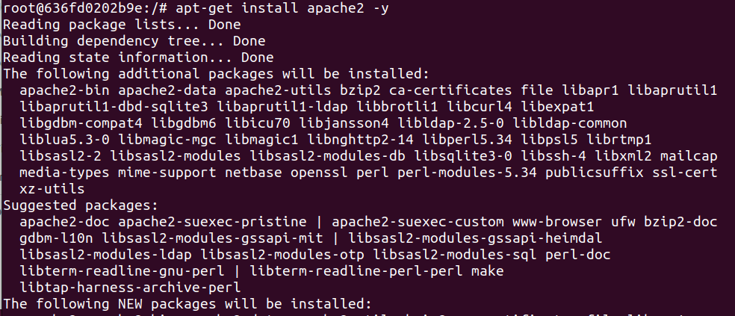

**[Enter the default root directory & change index.htl file’s content]**

**# cd /var/www/html**



**# /var/www/html# echo "Hello! to my Web Server..." >index.html**

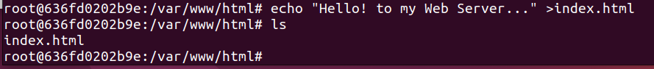

**[Restart Appache2 server]**

**# /var/www/html# service apache2 restart**

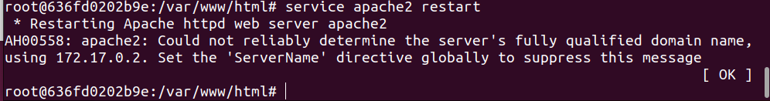

**[Now Access the index.html page from outside via ip address]**

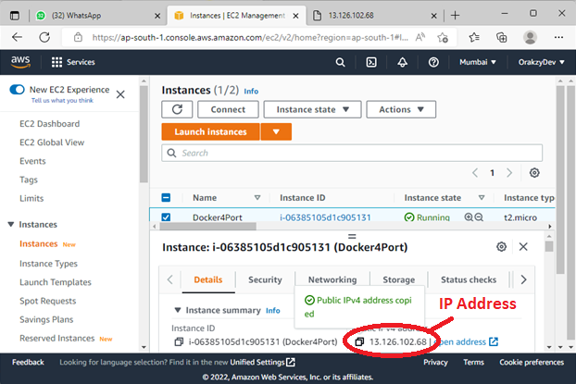

**[RESULT]**

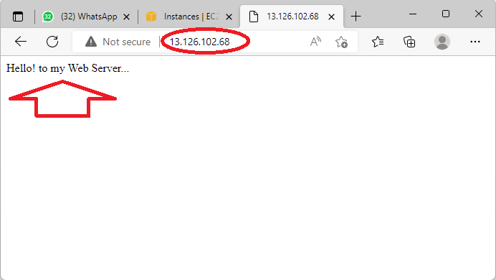

**[EXIT from current default directory]**

**# /var/www/html# exit**

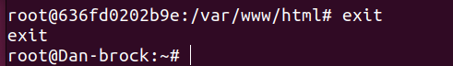

**[Run JENKINS container to see what happened when access Jenkins from outside via IP with 8080 port]**

**# docker run -td --name myjenkins -p 8080:8080 jenkins/jenkins:lts**

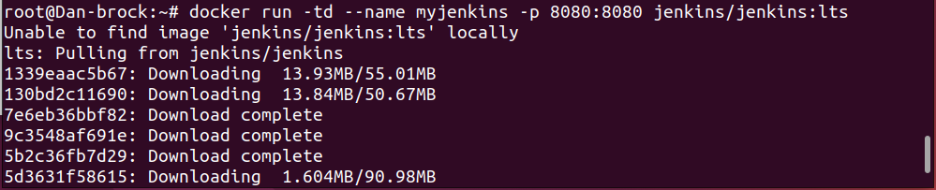

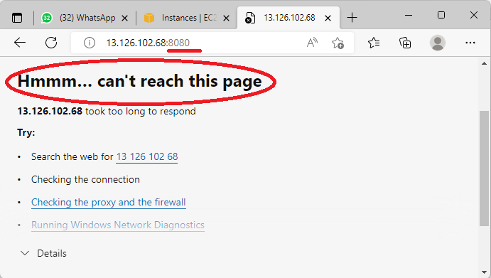

**[Because 8080 is not enable in host vm (instance) security group. Lets enable 8080)**

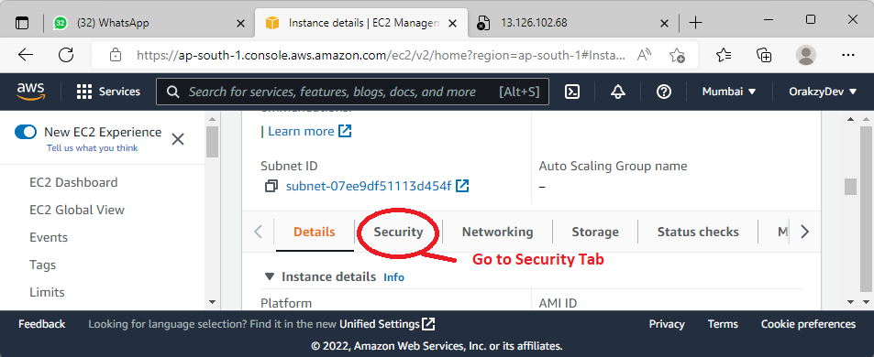

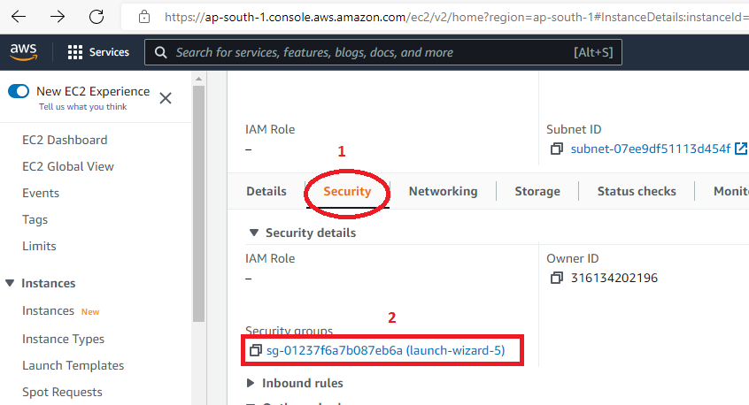

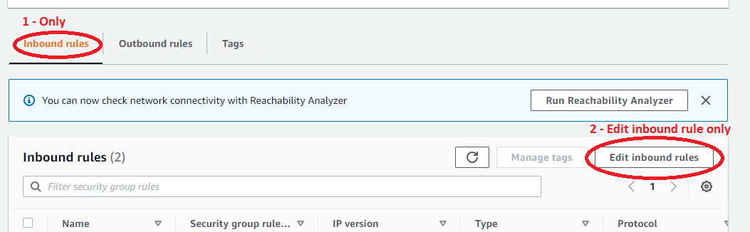

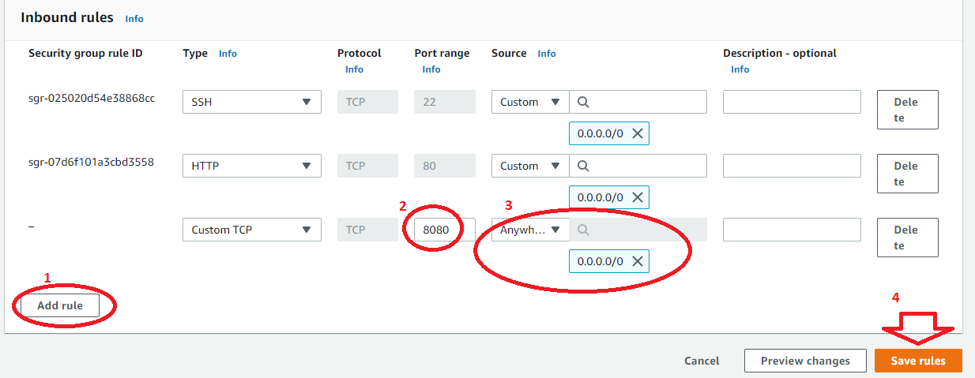

**[NOW accessible via 8080]**

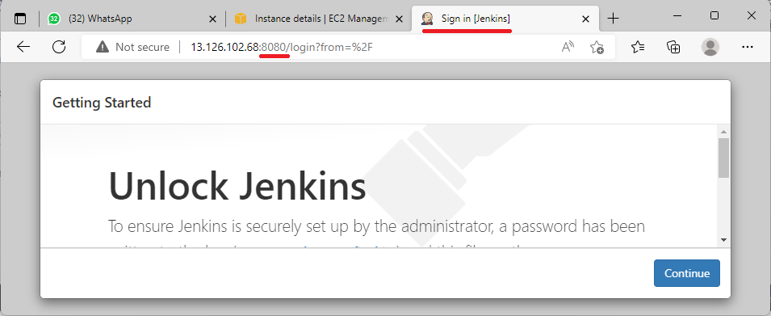

**[Note: IF containers are closed, Port mapped automatically deactivated and cann’t be accessible anymore**